Microservices in ASP.NET Core

What is a Microservice (simple idea)
Instead of one big app, you build small independent apps:
- Each does one job
- Each runs separately
- They talk to each other via HTTP (or messaging)
Example:
- Product Service
- Order Service

Step 1: Create Two Simple Microservices

Product Service (returns product data)
  - Create ASP.NET Core Web API:

Example Controller
[ApiController]
[Route("api/[controller]")]
public class ProductsController : ControllerBase
{
[HttpGet("{id}")]
public IActionResult GetProduct(int id)
{
var product = new
{
Id = id,
Name = "Laptop",
Price = 50000
};

return Ok(product);
}
}
Run it:
https://localhost:5001/api/products/1

Order Service (calls Product Service)
Create another API: OrderService

Step 2: Communicate Between Microservices
Method 1: HTTP Communication (Most Common for Beginners)
ASP.NET Core uses HttpClient

Order Controller Example
[ApiController]
[Route("api/[controller]")]
public class OrdersController : ControllerBase
{
private readonly HttpClient _httpClient;

public OrdersController(HttpClient httpClient)
{
_httpClient = httpClient;
}

[HttpGet("{productId}")]
public async Task<IActionResult> CreateOrder(int productId)
{
var response = await _httpClient.GetAsync(
$"https://localhost:5001/api/products/{productId}");

if (!response.IsSuccessStatusCode)
return BadRequest("Product not found");

var productData = await response.Content.ReadAsStringAsync();

var order = new
{
OrderId = 1,
Product = productData
};

return Ok(order);
}
}

Register HttpClient in Program.cs
builder.Services.AddHttpClient();

Flow of Execution
- User calls:
- /api/orders/1
- Order Service:
  - Calls Product Service
- Product Service:
  - Returns product data
- Order Service:
  - Combines data → returns order

Other Communication Methods (Overview)
- REST API (as we just implement above -- beginner friendly
- gRPC (faster, binary)
- Message Queue (Async communication) Tools : RabbitMQ, Apache Kafka

Working with API Gateway

What is an API Gateway?
- An API Gateway is a single entry point (like a receptionist or front door) for all client requests (from web apps, mobile apps, or external systems) in a microservices-based application.
- It acts as a reverse proxy — it receives incoming requests, processes them, and forwards (routes) them to the correct backend microservices. It then returns the response to the client.
- Think of it this way:
  - Without an API Gateway: Clients must know about every microservice (ProductService, OrderService, UserService, etc.), their URLs, ports, authentication rules, etc.
  - With an API Gateway: Clients only call one URL (e.g., https://api.yourapp.com), and the gateway handles everything behind the scenes.

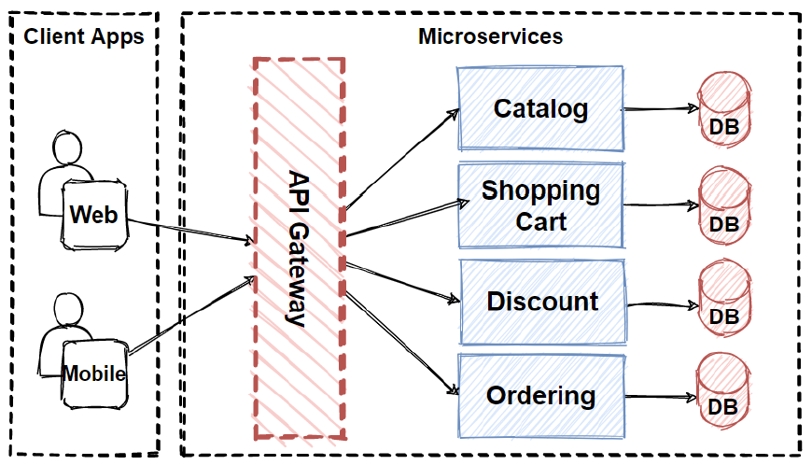

Benefits of Using an API Gateway
- Single Entry Point
- Request Routing
- Security (Centralized)
- Request Aggregation
- Easier Client Development
- Better Scalability & Maintainability
- Observability

How API Gateway Works (High-Level Flow)
- Client sends request → https://api.myshop.com/api/orders
- API Gateway(Separate Project – ASP.NET Core Project) receives it.
- Gateway applies policies: authentication? rate limit? logging?
- Gateway routes the request to the correct backend service (e.g., OrderService on internal port 7002).
- (Optional) Gateway calls other services if needed and aggregates data.
- Gateway returns the final response to the client.

Popular API Gateways in .NET
Since you are working with ASP.NET Core and have Product + Order services:
- Ocelot — Very beginner-friendly. Configured mostly via a simple ocelot.json file. Great for quick start with routing, rate limiting, caching, etc.
- YARP (Yet Another Reverse Proxy) — Made by Microsoft. More flexible and performant. You configure it in C# code or appsettings.json. Becoming very popular in 2025–2026.
Both are lightweight and easy to add to an ASP.NET Core project.

Steps to Implementation

Create the API Gateway Project with Ocelot
- Create a new ASP.NET Core Web API project named ApiGateway (you can delete default controllers/weather files).
- Install Ocelot via NuGet:
Visual Studio: Manage NuGet Packages → search Ocelot
- Add a configuration file ocelot.json in the project root (set "Copy to Output Directory" = "Copy if newer"):

{
"Routes": [
{
"UpstreamPathTemplate": "/api/products/{everything}",
"UpstreamHttpMethod": [ "GET", "POST", "PUT", "DELETE" ],
"DownstreamPathTemplate": "/api/products/{everything}",
"DownstreamScheme": "https",
"DownstreamHostAndPorts": [
{
"Host": "localhost",
"Port": 7001
}
]
},
{
"UpstreamPathTemplate": "/api/orders/{everything}",
"UpstreamHttpMethod": [ "GET", "POST", "PUT", "DELETE" ],
"DownstreamPathTemplate": "/api/orders/{everything}",
"DownstreamScheme": "https",
"DownstreamHostAndPorts": [
{
"Host": "localhost",
"Port": 7002
}
]
}
],
"GlobalConfiguration": {
"BaseUrl": "https://localhost:5000" // Your gateway URL
}
}

Explanation:
- Upstream = What the client calls (e.g., https://localhost:5000/api/products)
- Downstream = Where Ocelot forwards the request (to ProductService or OrderService)
- {everything} is a catch-all for path parameters/query strings.

Update Program.cs:

var builder = WebApplication.CreateBuilder(args);

// Load Ocelot configuration
builder.Configuration
.SetBasePath(builder.Environment.ContentRootPath)
.AddJsonFile("ocelot.json", optional: false, reloadOnChange: true)
.AddEnvironmentVariables();

builder.Services.AddOcelot(builder.Configuration);

var app = builder.Build();

app.UseOcelot().Wait(); // This is the key middleware

app.Run();

Important: Do not add app.MapControllers() or other endpoint mappings — Ocelot handles everything.

4. Run the Application
- Run ProductService on port 7001
- Run OrderService on port 7002
- Run ApiGateway on port 5000 (or 5001)
Test with Postman or browser:
- GET https://localhost:5000/api/products → forwards to ProductService
- GET https://localhost:5000/api/orders → forwards to OrderService
- POST https://localhost:5000/api/orders with body → forwards to OrderService

